Set-14
27.Write a Python programming to display a bar chart of the popularity of programming
Languages.
Code:
import matplotlib.pyplot as plt
language = ["Python","Java","C","C++","JavaScript"]
popularity = [90,80,70,60,85]
plt.bar(language, popularity)
plt.xlabel("Languages")
plt.ylabel("Popularity")
plt.title("Programming Language Popularity")
plt.show()
Output:
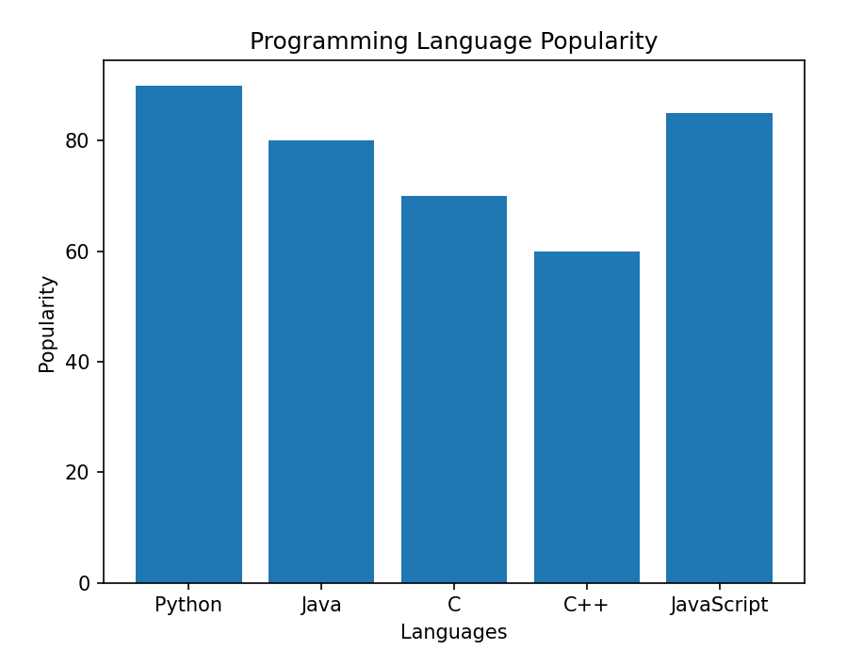
28.Write a Python programming to display a horizontal bar chart of the popularity of
programming Languages.
Code:
import matplotlib.pyplot as plt
language = ["Python","Java","C","C++","JavaScript"]
popularity = [90,80,70,60,85]
plt.barh(language, popularity)
plt.xlabel("Popularity")
plt.title("Horizontal Bar Chart")
plt.show()
Output:
